- You are ordering practice T-shirts for your soccer team. You can get the T-shirts in one of the three school colors (blue, gold, or white) and you can get long-sleeve or short-sleeve T-shirts. How many T-shirts are possible?

- Jar A contains 3 marbles (one blue, one red, and one green), jar B contains 3 marbles (one black, one purple and one yellow), and jar C contains 2 marbles (one orange and one white). How many outcomes are possible if you choose on marble from each jar?

- In Minnesota, the standard configuration of a license plate is 3 digits followed by 3 letters. How many license plates can be made if the letters and digits can be repeated?

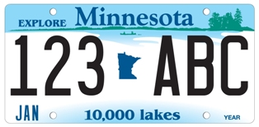

- You are given a random 4-digit personal identification number (PIN) for your bank card. How many 4 digit PINs are possible if the numbers can be repeated?

- You roll a number cube 5 times. How many outcomes are possible?

- Radio station call letters, such as WROC, KFAN and KDWB, consist of 4 letters. The call letters need to begin with either a W or a K. How many different call letters are possible if the letters can be repeated?

In Exercise 7 and 8, use the spinners shown.
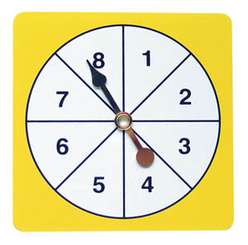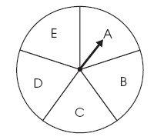
Spinner 1 Spinner 2

- Suppose you spin spinner 1, and then spin spinner 2. Find the number of outcomes.

- Suppose you spin spinner 1, and then spin spinner 1 again. Find the number of outcomes.

